SANSKAAR PATNI
180905134 CSE-C 23
CD LAB 7

//LEXICAL ANALYSER
#include <stdio.h>
#include <stdlib.h>
#include <string.h>

int row = 1, column = 1;
int symboltableindex=-1;
int lexemeindex=0;
char buff[80];
char dbuf[80]="int";
struct Token
{
char *token_name;
int index;
int row,col; //Line numbers.
char *type;
};

struct Node
{
char lexeme[20];
int size;
char type[50];
}symboltable[10][100];

char symboltablename[10][100];
int symboltablesize[10];
const char *keywords[] = {
"auto",
"break",
"case",
"char",
"continue",
"do",
"default",
"const",
"double",
"else",
"enum",
"extern",
"for",
"if",
"include",
"goto",
"float",
"int",
"long",
"register",
"return",
"signed",
"static",
"sizeof",
"short",
"struct",
"switch",
"typedef",
"union",
"void",
"while",
"volatile",
"unsigned",
"printf",
"scanf",
"bool",
"main"
};
const char *dataTypes[] = {
"int","void","char","float","bool"
};

const char specialsymbols[]={'?',';',':',',', '(', ')', '[', ']', '{', '}'};

int isKeyword(char* id) {
for(int i = 0; i < sizeof(keywords)/sizeof(char*); i++) {
if(strcmp(id, keywords[i]) == 0)
return 1;
}
return 0;
}

int isDataType(char* id) {
for(int i = 0; i < sizeof(dataTypes)/sizeof(char*); i++) {
if(strcmp(id, dataTypes[i]) == 0)
return 1;
}
return 0;
}

int isspecialSymbol(char id) {
for(int i = 0; i < sizeof(specialsymbols)/sizeof(char); i++) {
if(id == specialsymbols[i])
return 1;
}
return 0;
}

int isAlpha(char in) {
if((in >= (int)('A') && in <= (int)('Z')) || (in >= (int)('a') && in <= (int)('z')) )
return 1;
return 0;
}

int isDigit(char in) {
if((in >= (int)('0') && in <= (int)('9')))
return 1;
return 0;
}

void printToken(struct Token tk)
{
printf("< %s , %d , %d >\n", tk.token_name, tk.row, tk.col);
}

void fillToken(struct Token* tok, char* token_name, int row, int column) {
tok->token_name = token_name;
tok->row = row;
tok->col = column;
}

void printLexeme(int i, int j)
{
printf(" %d \t",j+1);
printf(" %s \t\t",symboltable[i][j].lexeme);
printf(" %s \t",symboltable[i][j].type);
printf(" %d \n",symboltable[i][j].size);
}
void printSymbolTable()
{
int i,j;
for(i=0;i<=symboltableindex;i++)
{
printf("------------------------------------------------------------\n");
printf("Symbol Table for %s:\n", symboltablename[i]);
printf(" \t Lexeme_name \t Type \t Size \n");
for(j=0;j<symboltablesize[i];j++)
{
printLexeme(i,j);
}
}
}

void createSymbolTable(char *buf)
{
symboltableindex++;
lexemeindex=0;
strcpy(symboltablename[symboltableindex],buf);
// printf("Symbol table index%d\n",symboltableindex);
// printf("Lexeme index%d\n",lexemeindex);
}

int searchSymbolTable(char *buf)
{
int i;
for(i=0;i<lexemeindex;i++)
{
if(strcmp(symboltable[symboltableindex][i].lexeme,buf)==0)
return 1;
}
return 0;
}
void insertSymbolTable(char *buff,char *dbuf,FILE *fp){
int arrayMultiplier=1;
int arrayLength=0;
if(searchSymbolTable(buff))return;
else{
//bringing the pointer one back to read whether it is an aray or function
fseek(fp,-1,SEEK_CUR);
char c=fgetc(fp);
if(c=='(')
{
if(strcmp(dbuf,"none")!=0)
createSymbolTable(buff);
else{
strcpy(symboltable[symboltableindex][lexemeindex].lexeme,buff);
symboltable[symboltableindex][lexemeindex].size = -1;
strcpy(symboltable[symboltableindex][lexemeindex].type,"Func");
lexemeindex++;
symboltablesize[symboltableindex]=lexemeindex;
}
}
else{
if(c=='[')
{
c=fgetc(fp);
while(c!=']'){
//converting char digit to single digit
arrayLength=arrayLength+((int)c-48)*10;
c=fgetc(fp);
}
arrayMultiplier=arrayLength;
}
strcpy(symboltable[symboltableindex][lexemeindex].lexeme,buff);
int sizeDataType=0;
if(strcmp(dbuf,"int")==0){
sizeDataType=4;
}else if(strcmp(dbuf,"char")==0){
sizeDataType=1;
}else if(strcmp(dbuf,"float")==0){
sizeDataType=8;
}else if(strcmp(dbuf,"bool")==0){
sizeDataType=1;
}
symboltable[symboltableindex][lexemeindex].size = sizeDataType*arrayMultiplier;
strcpy(symboltable[symboltableindex][lexemeindex].type,dbuf);
lexemeindex++;
symboltablesize[symboltableindex]=lexemeindex;
}
}
}

struct Token getNextToken(FILE* fp) {
int k = 0;
char c = fgetc(fp);
struct Token tok;
while (c != EOF) {
// if(c==EOF)
// {
// strcpy(tok.token_name,"eof");
// tok.row=row;
// tok.col=column;
// return(tok);
// }
if (c == '#') {
buff[0] = '\0';
int k = 0;
c = fgetc(fp);

while(isAlpha(c))
{
buff[k++] = c;
c = fgetc(fp);
}
fseek(fp, -1, SEEK_CUR);
buff[k]='\0';

if(strcmp(buff,"include") == 0 || strcmp(buff,"define") == 0)
{
c = fgetc(fp);
while(c != '\n') {
c = fgetc(fp);
}
row++;
column = 0;
c = fgetc(fp);
continue;
}
fillToken(&tok, "#", row, column);
column++;
return tok;
}
// Remove comments
if(c == '/') {
c = fgetc(fp);
int k = 0;
column++;
if(c == '/') {
while(c != '\n')
c = fgetc(fp);
row++;
column = 0;
c = fgetc(fp);
continue;
}
else if (c == '*') {
do {
while(c != '*') {
if(c == '\n') {
row++;
column = 0;
}
else {
column++;
}
c = fgetc(fp);
}
if(c == '\n') {
row++;
column = 0;
}
else {
column++;
}
c = fgetc(fp);
} while(c != '/');
}
}
buff[0] = '\0';
if(c == '=')
{
c = fgetc(fp);
if(c == '=') {
fillToken(&tok, "==", row, column);
column += 2;
}
else {
fillToken(&tok, "=", row, column);
column++;
fseek(fp, -1, SEEK_CUR);
}
return tok;
}
else if(c == '<') {
c = fgetc(fp);
if(c == '=') {
fillToken(&tok, "<=", row, column);
column += 2;
}
else {
fillToken(&tok, "<", row, column);
column++;
fseek(fp, -1, SEEK_CUR);
}
return tok;
}
else if(c == '>') {
c = fgetc(fp);
if(c == '=') {
fillToken(&tok, ">=", row, column);
column += 2;
}
else {
fillToken(&tok, ">", row, column);
column++;
fseek(fp, -1, SEEK_CUR);
}
return tok;
}
else if(c == '!') {
c = fgetc(fp);
if(c == '=') {
fillToken(&tok, "!=", row, column);
column += 2;
}
else {
fillToken(&tok, "!", row, column);
column++;
fseek(fp, -1, SEEK_CUR);
}
return tok;
}
else if(c == '&') {
c = fgetc(fp);
if(c == '&') {
fillToken(&tok, "&&", row, column);
column += 2;
}
else {
fillToken(&tok, "&", row, column);
column++;
fseek(fp, -1, SEEK_CUR);
}
return tok;
}
else if(c == '|') {
c = fgetc(fp);
if(c == '|') {
fillToken(&tok, "||", row, column);
column += 2;
}
else {
fillToken(&tok, "|", row, column);
column++;
fseek(fp, -1, SEEK_CUR);
}
return tok;
}
else if(isspecialSymbol(c)) {
buff[0] = c;
buff[1] = '\0';
fillToken(&tok, buff, row, column);
column++;
if(buff[0]==';')strcpy(dbuf,"int");
return tok;
}
else if(c == '+') {
c = fgetc(fp);
if(c == '+') {
fillToken(&tok, "++", row, column);
column += 2;
}
else if(c == '=') {
fillToken(&tok, "+=", row, column);
column += 2;
}
else {
fillToken(&tok, "+", row, column);
column++;
fseek(fp, -1, SEEK_CUR);
}
return tok;
}
else if(c == '-') {
c = fgetc(fp);
if(c == '-') {
fillToken(&tok, "--", row, column);
column += 2;
}
else if(c == '=') {
fillToken(&tok, "-=", row, column);
column += 2;
}
else {
fillToken(&tok, "-", row, column);
column++;
fseek(fp, -1, SEEK_CUR);
}
return tok;
}
else if(c == '*') {
c = fgetc(fp);
if(c == '=') {
fillToken(&tok, "*=", row, column);
column += 2;
}
else {
fillToken(&tok, "*", row, column);
column++;
fseek(fp, -1, SEEK_CUR);
}
return tok;
}
else if(c == '/') {
c = fgetc(fp);
if(c == '=') {
fillToken(&tok, "=/", row, column);
column += 2;
}
else {
fillToken(&tok, "/", row, column);
column++;
fseek(fp, -1, SEEK_CUR);
}
return tok;
}
else if(isAlpha(c)) {
// printf("%c",c);
int k = 0;
do {
buff[k++] = c;
c = fgetc(fp);
// printf("%c",c);
} while(isAlpha(c) || isDigit(c) || c == '_');
fseek(fp, -1, SEEK_CUR);
buff[k] = '\0';
// printf("WORD %s\n", id);
if(isKeyword(buff)) {
fillToken(&tok, buff, row, column);
if(isDataType(buff)){
// printf("%s",dbuf);
// printf("is a datatype\n");
// dbuf[0]='\0';
// printf("Changing dbuf %s",buff);
strcpy(dbuf,buff);
// printf("%s",dbuf);
}
}
else {
// printf("I was here %s",buff);
fillToken(&tok, "id", row, column);
//insertSymbolTable(buff,dbuf,fp);
}
column += k;
return tok;
}
else if(c == '\"') {
int k = 0;
buff[k++] = c;
do {
c = getc(fp);
buff[k++] = c;
} while((char)c != '\"');
buff[k] = '\0';
fillToken(&tok, buff, row, column);
column += k;
return tok;
}
else if(isDigit(c)) {
int k = 0;
do {
buff[k++] = c;
c = getc(fp);
} while(isDigit(c));
buff[k] = '\0';
fillToken(&tok, "num", row, column);
fseek(fp, -1, SEEK_CUR);
column += k;
return tok;
}
else {
if(c != '\n') {
column++;
}
else {
row++;
column = 1;
}
}
c = fgetc(fp);
// printf("%c\n",c);
}
tok.row = -1;
return tok;
}

// int main(int argc, char const *argv[]) {
// FILE *fa;
// char c;
// fa = fopen(argv[1], "r");

// if(fa == NULL) {
// printf("Cannot open file\n");
// exit(0);
// }

// do {
// struct Token tok = getNextToken(fa);
// if(tok.row == -1)
// break;
// printToken(tok);
// // c=fgetc(fa);
// // fseek(fa, -1, SEEK_CUR);
// // printf("%c going for the second token \n",c);
// } while (1);
// printf("\n");
// printSymbolTable();
// fclose(fa);
// return 0;
// }

//PARSER
#include<stdio.h>
#include<stdlib.h>
#include<string.h>
#include<fcntl.h>
#include "symbolTable.c"

struct Token retToken;
FILE *fp;

void match();
void Program();
void declarations();
int data_type();
void identifier_list();
void identifier_listprime();
void assign_stat();
void assign_statprime();

void valid()
{
printf("\n----------PARSER SUCCESS!----------\n\n");
exit(0);
}

void invalid(char *follow)
{
printf("\n----------PARSER ERROR!----------\n\n");
printf("Error reported at row no. %d column no. %d\n", retToken.row, retToken.col);
printf("Expected %s\n", follow);
exit(0);
}

int main(int argc, char const *argv[])
{
fp = fopen(argv[1], "r");
if (fp == NULL){
printf("Cannot open file \n");
exit(0); }
//printf("File opened\nParsing Started\n");
Program();
if(strcmp(retToken.token_name,"eof")==0||feof(fp))
valid();
else
invalid("EOF");
}

void match()
{
//printf("Inside Match\n");
retToken=getNextToken(fp);
if(retToken.row == -1)
return;
if(strcmp(retToken.token_name,"eof")==0)
return;
printToken(retToken);
}

void Program()
{
match();
if(strcmp(retToken.token_name,"main")==0)
{
match();
if(strcmp(retToken.token_name,"(")==0)
{
match();
if(strcmp(retToken.token_name,")")==0)
{
match();
if(strcmp(retToken.token_name,"{")==0)
{
match();
declarations();
assign_stat();
if(strcmp(retToken.token_name,"}")==0)
{
match();
}
else
{
invalid("}");
}
}
else
{
invalid("{");
}
}
else
{
invalid(")");
}
}
else
{
invalid("(");
}
}
else
{
invalid("main");
}
}

void declarations()
{
if(data_type())
{
identifier_list();
if(strcmp(retToken.token_name,";")==0)
{
match();
declarations();
}
else
{
invalid(";");
}
}
}

int data_type()
{
if(strcmp(retToken.token_name,"int")==0 )
{
match();
return 1;
}
else if(strcmp(retToken.token_name,"char")==0 )
{
match();
return 1;
}
else
{
return 0;
}
}

void identifier_list()
{
if(strcmp(retToken.token_name,"id")==0)
{
match();
identifier_listprime();
}
else
{
invalid("id");
}
}

void identifier_listprime()
{
if(strcmp(retToken.token_name,",")==0)
{
match();
identifier_list();
}
}

void assign_stat()
{
if(strcmp(retToken.token_name,"id")==0)
{
match();
if(strcmp(retToken.token_name,"=")==0)
{
match();
assign_statprime();
}
else
{
invalid("=");
}
}
else
{
invalid("id");
}
}

void assign_statprime()
{
if(strcmp(retToken.token_name,"id")==0)
{
match();
if(strcmp(retToken.token_name,";")==0)
{
match();
}
else
{
invalid(";");
}
}
else if(strcmp(retToken.token_name,"num")==0)
{
match();
if(strcmp(retToken.token_name,";")==0)
{
match();
}
else
{
invalid(";");
}
}
else
{
invalid("id | num");
}
}

test1.c:
main(){
int a,b ;
char c;
a=25;
}
o/p screen shot for test1.c :
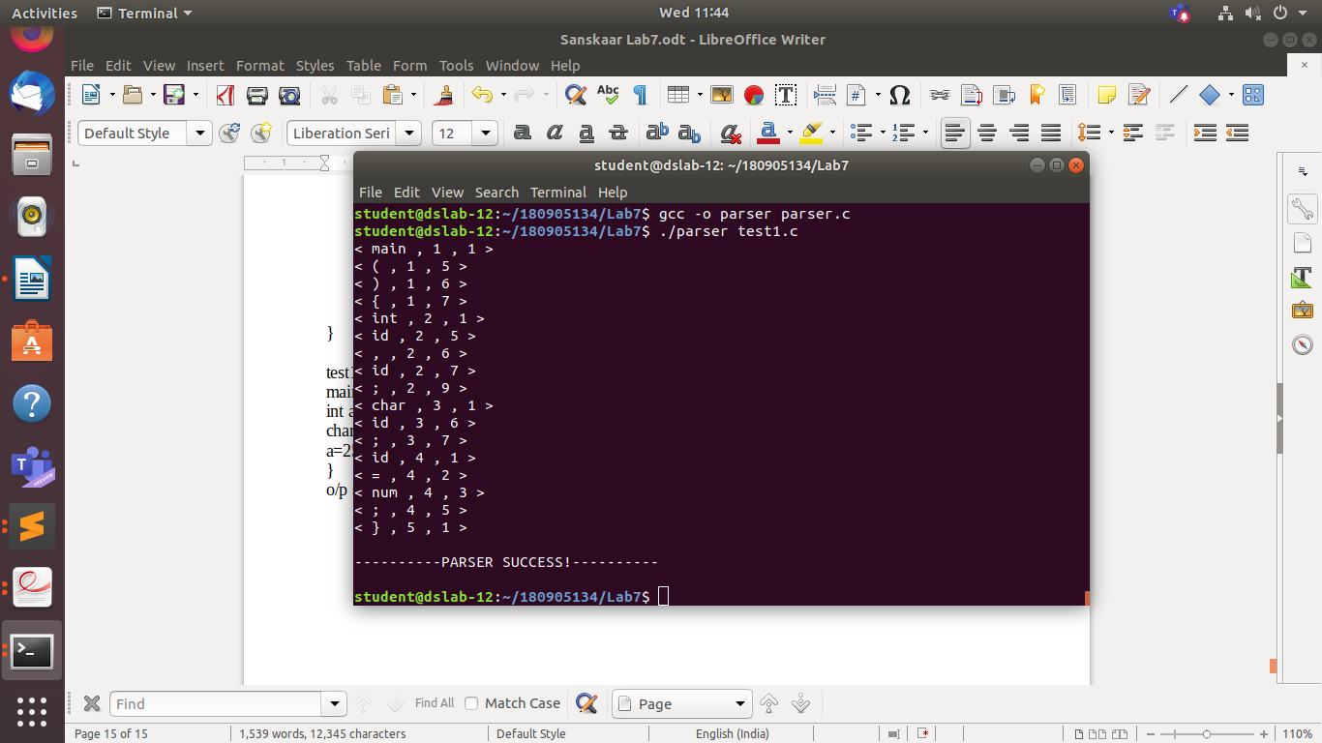
test2.c:
main(){
int a,b
char c;
a=25;
}
o/p screen shot for test2.c :
